1. Correct Test Method Header Name 1
2. In Test method list, show test method No 1
3. In Test method reference list, show test method name 1
4. Sorting button of list must be checked and corrected
5. Specification Input field in material setup should be enlarged when inputting value ( Text Area )
6. Warehouse request report doesn’t show complete value ( for Manufacturer & Sample Details )
7. In Warehouse request form, Without clicking add button receive quantity doesn’t get populated ( in case of single value )
8. 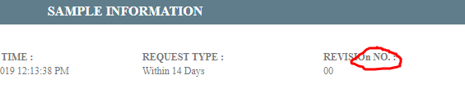
9. Client name & Client Id should be populated from dropdown in sampling form
10. Storage Condition will be in material setup form and will retrieved in sampling form
11. In Sampling Form, Sampling Equipment should be retrieved from Sampling Equipment Setup not From Equipment profile. So Sampling Equipment Setup form should be created
12. 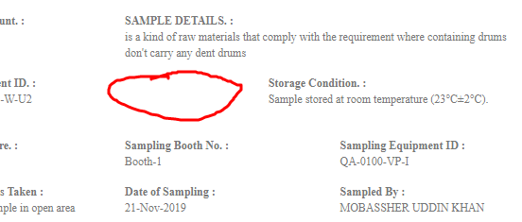
13. 
14. In distribution supervisor dashboard, New request view doesn’t show full information ( missing: Materials name etc )
15. Work order Accept & NC button must be put in analyst new request view page
16. Time Taken hasn’t been included
17. Attached result file must be viewable with every result
18. In case of incomplete result distribution supervisor can’t verify result and proceed to TM